A Shella Films and Little By Little Films production
in association with Impact Partners and Chicken & Egg Pictures

UNREST
Directed by Jennifer Brea
97 minutes / Cert tbc / In English and Danish
http://www.unrest.film/
https://twitter.com/unrestfilm
https://www.facebook.com/unrestfilm/

Winner: Special Jury Prize Documentary Editing — Sundance Film Festival
Winner: Illuminate Award in partnership with Wellcome — Sheffield Doc/Fest
Official Selection: SXSW, CPH:DOX and Hot Docs

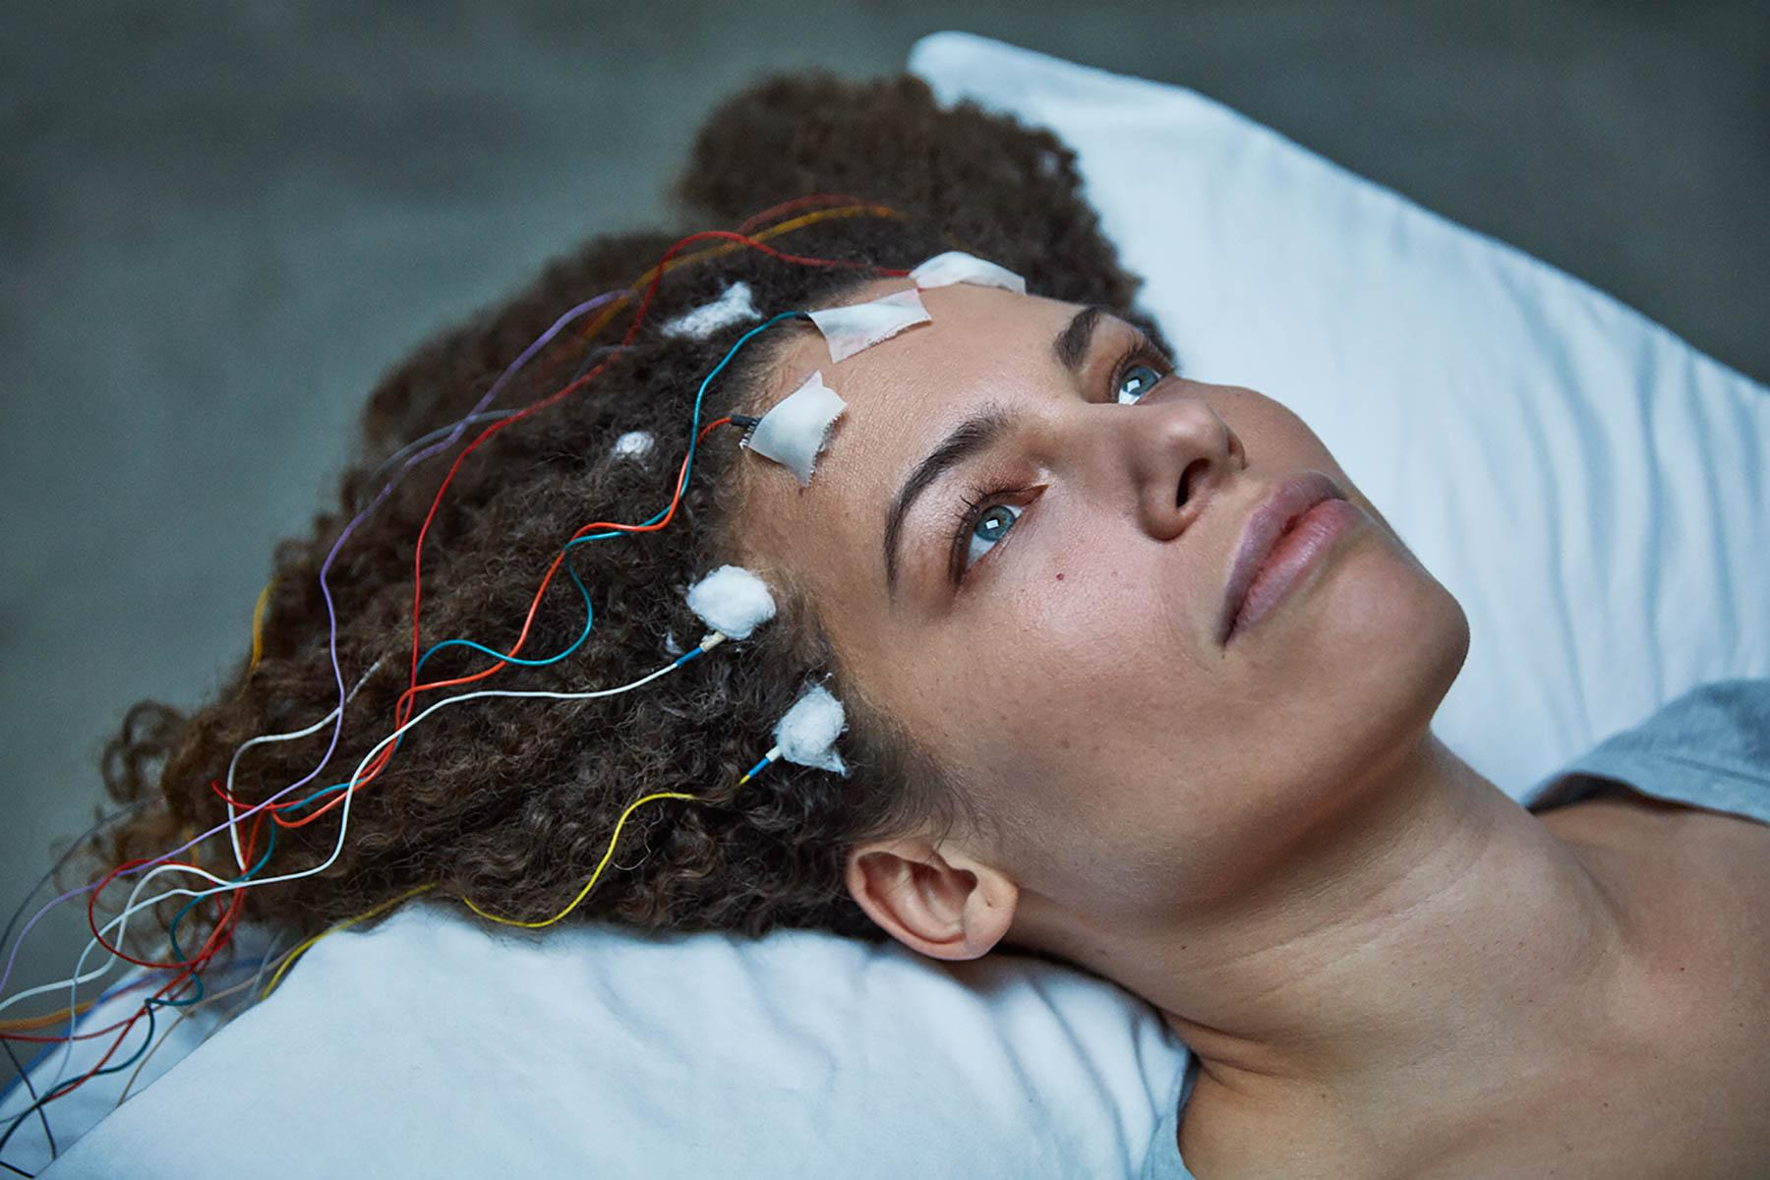

Release date details:
20 October 2017
Picturehouse Central plus 10 venues nationwide including a Q&A tour
with the director Jennifer Brea.
BFI Southbank Preview with Jennifer Brea: 16 October 2017

Sundance Film Festival award-winning film Unrest, an intimate portrait of filmmaker Jennifer Brea’s courageous fight to overcome the disabling disease Myalgic Encephalomyelitis (ME) — also known as chronic fatigue syndrome — will have its UK theatrical on October 20 in London and cities nationwide, followed by a Q&A tour with Jennifer Brea.

Aged 28 and brilliant — working on her PhD at Harvard and about to marry the love of her life — Jen suffered, in a short space of time, a series of viral infections that left her incapacitated. So ill she becomes bedbound, often in excruciating pain, and looking for answers. Disbelieved by doctors and determined to live, she turns her camera on herself and her community, a hidden world of millions confined to their homes and bedrooms by ME. Though Jen and Omar may have to accept that they will never live the life they originally dreamed about, together they find resilience, strength, and meaning in their community and each other.

Unrest is also a love story; how Jen and her new husband Omar forge their relationship while dealing with her mysterious illness is at once heartbreaking, inspiring and funny.

Jen began a video diary on her iPhone to convey the seriousness and depth of her symptoms to her doctors. “If you see me screaming, do not try to help, do not back away. Get closer. We already know there is very little you can do for me. In those moments, the camera is the greatest act of love and care you can provide.” Director Jennifer Brea persuading her husband Omar Wasow and Directors of Photography to carry on filming.She saw every kind of specialist: infectious disease doctors, rheumatologists, cardiologists, endocrinologists, even a psychiatrist. Her psychiatrist told her, “It’s clear you’re really sick, but not with anything psychiatric. I hope they can find out what’s wrong with you”. Finally her neurologist diagnosed ‘conversion disorder’, suggesting that symptoms could be traced back to a psychological trigger that she could not remember.

The video diary eventually led her to make the feature documentary film Unrest, which this year has been awarded at international film festivals including Sundance Film Festival and Sheffield Doc/Fest.

Jennifer Brea: “I couldn’t countenance the prospect of spending the rest of my life in bed. But more than that, I couldn’t countenance living in a world where we allowed this to happen. What I saw angered me, and I knew this was a compelling story.
“In making the film I begun to uncover the layers of misogyny and assumptions that medicine and society have about female patients being unreliable narrators of their own stories.”

Many of the people Jen connected with were bedbound, isolated, without treatment or care, and often disbelieved.
“I went online and met thousands of people, all over the world, living the same experience. The key symptom we share is that whenever we exert ourselves, physically or mentally, we pay and we pay hard.”

She started to reach out to other patients and to document their stories, including 23 year old Jessica Taylor from Kent who has been bedridden since she was 15; Karina Hansen from Denmark who was forcibly institutionalised and denied contact with her parents because doctors in Denmark consider ME to be a psychosomatic health issue; and Ron Davis, a Stanford Professor of Genetics and a co-investigator on the Human Genome Project, who embarks on a mission to find a cure for his son Whitney when he learns medicine has little to offer.

The film is a feat of disability filmmaking, made with an international team and using innovative technologies, which allowed Jen to travel the world and film as if she was in the room. When shooting began Jen was confined to her bed 99% of the time. The global producing team — Patricia E. Gillespie in the US, Lindsey Dryden in the UK, and Anne Troldtoft Hjorth in Denmark — relayed the shooting environment to her using live feeds and text messaging. By conducting interviews via Skype and an iPad teleprompter — a sort of poor man’s Interrotron – Jen had a live feed that allowed her to see in real time what the DP was shooting on the ground — and so she directed the film from her bed.

Unrest received its premiere in Official Competition at Sundance Film Festival 2017 where it was awarded the Special Jury Award, Editing and has since screened at SXSW, CHP:DOX, Hot Docs, River Run (Audience Award for Best Documentary Feature), Nashville Film Festival (Grand Jury Award for Best Documentary Feature), and the Sheffield Doc/Fest (Illuminate Award), among other festivals.

Inspired by the documentary, Unrest VR is an interactive non-fiction experience providing an immersive journey into Jen’s experience which contrasts the painful solitary confinement of a bedroom world with the kinetic freedom of an inner dreamscape. Unrest VR, which won the Alternate Realities VR Award at Sheffield Doc/Fest, is co-directed by Brea and Amaury La Burthe and co-produced by Arnaud Colinart (La Burthe and Colinart previously created Notes on Blindness – A Journey Beyond Sight) and Lindsey Dryden, and will be presented in selected cinemas in London and nationwide (details to be announced).

Unrest is supported by the Sundance Institue, Chicken & Egg Pictures, the Harnisch Foundation, BRITDOC’s Good Pitch, the Tribeca Film Institute, the Fledgling Fund, IFP, and over 2,593 Kickstarter backers.

Unrest is one of the augural films to be release with the support of Sundance Institute’s Creative Distribution Fellowship which empowers entrepreneurial Sundance filmmmakers navigating the changing business of independent film.

The release of Unrest in the UK was made possible with the support of the BFI, awarding funds from the National Lottery.

About the filmmaker
Jennifer Brea is an independent documentary filmmaker based in Los Angeles. She has an AB from Princeton University and was a PhD student at Harvard until sudden illness left her bedridden. In the aftermath, she rediscovered her first love, film. Her feature documentary, Unrest, premiered at the Sundance Film Festival in January, where it won a Special Jury Prize. She is also co-creator of Unrest VR, winner of the Sheffield Doc/Fest Alternate Realities Award. An activist for invisible disabilities and chronic illness, she co-founded a global advocacy network, #MEAction, launched a global day of protest, #MillionsMissing,
and is a TED Talker.

TED Talk: What happens when you have a disease the doctors can’t diagnose by Jen Brea

Unrest (2017, U.S., 97 min) Directed by Jennifer Brea. Produced by Jennifer Brea, Lindsey Dryden, Patricia E. Gillespie, and Alysa Nahmias. Executive Produced by Lisa Gunn, Donna Fairman Wilson, Dan Cogan, Ian Darling, Regina K. Scully, and Lynda Weinman. Edited by Kim Roberts and Emiliano Battista. Cinematography by Sam Heesen and Christian Houge Laursen. Original Score by Bear McCreary. With Jennifer Brea, Omar Wasow, Jessica Taylor, Leeray Denton, Randy Denton, Casie Jackson, Karina Hansen, Ron Davis and Whitney Dafoe. In English and Danish.

For further information contact:

Sarah Harvey Publicity:

Sarah Harvey – sarah@sarahharveypubicity.co.uk
Hayley Willis – hayley@sarahharveypublicity.co.uk

For science and health press media enquiries contact:

Steve Harman: steveharman57@gmail.com
Penny Lukats: penny@sensocommunications.com

